# Abstract

As widely said “Prevention is better than cure”, prediction of diseases and epidemic outbreak would lead to an early prevention of an occurrence of a disease. “Disease Prediction” web system based on ML algorithm predicts the disease of the user on the basis of the symptoms that user provides as an input to the system. The system analyzes the symptoms provided by the user as input and gives the probability of the disease as an output. Along with that it suggests some common medicines and consult to a doctor. This web application allows user to consult themselves while sitting at their home in COVID pandemic. As the use of internet is growing every day, people are always curious to know different new things. People always try to refer to the internet if any problem arises. People have access to internet than hospitals and doctors. People do not have immediate option when they suffer with particular disease. So, this system can be helpful to the people as they have access to internet 24 hours. The main focus is to use machine learning in healthcare to supplement patient care for better results. Machine learning has made it easier to identify different diseases and diagnoses correctly. Predictive analysis with the help of efficient multiple machine learning algorithms helps to predict the disease more correctly and help to treat patients.

# Table of Contents

|  |  |
| --- | --- |
| 1. Introduction. | 07 |
| 1.1 Purpose | 08 |
| 1.2 Problem Statement | 08 |
|  |  |
| 2. Literature survey | 09 |
| 3.Proposed Method/Algorithm | 10 |
| 3.1 Problem Definition | 10 |
| 3.2 Proposed Idea/System | 10 |
| 3.3 Algorithms | 11 |
| 3.3.1 Decision Tree | 11 |
| 3.3.2 Random Forest | 12 |
| 3.3.3 Naive Bayes | 13 |
| 3.4 System Architecture | 14 |
| 3.5 Requirement Specification | 15 |
| 3.6 Flowcharts / DFDs / UML | 16 |
| 3.7 Design and Test Steps | 17 |
| 3.7.1 Homepage  3.7.2 Patient UI | 17  18 |
| 3.7.3 Doctor UI | 28 |
| 4 .Performance Study | 33 |
| 4.1 Implementation Environment | 33 |
| 4.2 Result and Analysis | 36 |
| 5. Testing | 37 |
| 6. Project Timeline | 40 |
| 7. Conclusions and Future Work | 41 |
| 8. References | 42 |

# Introduction

It is estimated that more than 70% of people in India are prone to general body diseases like viral, flu, cough, cold, etc., in every 2 months. Because many people don't realize that the general body diseases could be symptoms to something more harmful, 25 % of the population succumbs to death because of ignoring the early general body symptoms. This could be a dangerous situation for the population and can be are alarming. Hence identifying or predicting the disease at the earliest is very important to avoid any unwanted casualties.

According to Survey Conducted by National Patients Safety Foundations 42% of medical patients feel they have had experienced medical error or missed diagnosis. Patient safety is major concern in healthcare sector.

The purpose of this system is to provide prediction for the general and more commonly occurring disease that when unchecked can turn into fatal disease. The system applies Machine Learning Algorithms- Decision tree, Naïve Byes, Random Forest. This system will predict the most possible disease based on the given symptoms and System suggests Specialist doctors for Predicted Disease and Patient is able to consult with doctor by using real time chat and video calling facility.

## Purpose

The purpose of this system is that patient can contact doctor anytime without wasting lot of resources like time, money and efforts. Doctors can get more clients online. Patient can talk about their illness and get instant diagnosis. The main purpose of this project is to predict the disease so that early treatment can be given to the patients which can reduce the risk of life and save life of patients and cost of treatment of diseases can be reduced up to some extent by early recognition.

## Problem Statement

**Medicator – Online disease prediction and doctor’s consultation.**

Create a platform or application to identify the disease by processing its symptoms and providing the facility of doctor’s consultation using python and machine learning.

# Literature Survey

By referring paper [1], we understood about an idea of comparisons of different algorithms such as k-NN, Naïve Bayes, Random Forest, J48, using performance measures like ROC, kappa statistics, RMSE and MAE in WEKA tools, and also compared the classifiers on various accuracy measures. The conclusion reached of this research was that Random Forest has better accuracy for chronic kidney dataset that was used.

By referring paper [2], we understood that the authors K.M. Al-Aidaroos, A.A. Bakar and Z. Othman have conducted the research for the best medical diagnosis mining technique. For this authors compared Naïve Bayes with five other classifiers i.e. Logistic Regression (LR), KStar (K*), Decision Tree (DT), Neural Network (NN) and a simple rule-based algorithm (ZeroR). For this, 15 real-world medical problems from the UCI machine learning repository (Asuncion and Newman, 2007) were selected for evaluating the performance of all algorithms. In the experiment it was found that NB outperforms the other algorithms in 8 out of 15 data sets so it was concluded that the predictive accuracy results in Naïve Bayes is better than other techniques.

## Existing Systems:

In current scenario of market there is no such system/application to predict the disease by its symptoms & consult with respective doctors.

# Proposed Method/Algorithm

## 3.1 Problem Definition

There are so many articles present about prediction of disease using machine learning but these articles are about mainly related to heart and brain diseases. Generally there is no such system exist which is used for prediction of general diseases by using more than one algorithm. So Medicator helps for the prediction of the general diseases by using machine learning with the help of three algorithms.

## 3.2 Proposed Idea/System

The proposed system of disease prediction using machine learning where we have used prediction algorithms to build a system which predicts the disease of the patient using the symptoms which is provided by patient. We are comparing the symptoms with the system’s dataset that is previously available, using those datasets and comparing with the patient's symptoms, we will predict the disease of the patient. The dataset and symptoms go to the prediction model of the system where the data is pre-processed for the future references and then the feature selection is done by the user where he will enter the various symptoms. Then the classification to those data is done with the help of algorithms and techniques such as Decision Tree, Naive Bayes, Random Forest.

**3.3 Algorithms:**

**3.3.1 Decision tree:**

* Decision Tree is a **supervised learning technique**that can be used for both classification and Regression problems, but mostly it is preferred for solving Classification problems. It is a tree-structured classifier, where**internal nodes represent the features of a dataset, branches represent the decision rules** and **each leaf node represents the outcome.**
* In a Decision tree, there are two nodes, which are the **Decision Node** and**Leaf Node.** Decision nodes are used to make any decision and have multiple branches, whereas Leaf nodes are the output of those decisions and do not contain any further branches.

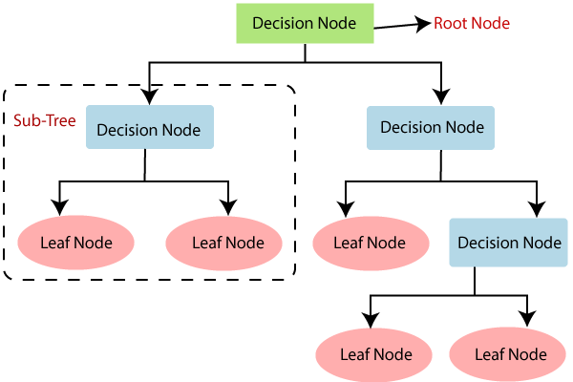

## Fig.1 Decision Tree Algorithm.

**3.3.2 Random Forest:**

## Random Forest is a popular machine learning algorithm that belongs to the supervised learning technique. It can be used for both Classification and Regression problems in ML. It is based on the concept of **ensemble learning**,**** which is a process of combining multiple classifiers to solve a complex problem and to improve the performance of the model.

## 

## Fig. 2 Random Forest Algorithm.

***"Random Forest is a classifier that contains a number of decision trees on various subsets of the given dataset and takes the average to improve the predictive accuracy of that dataset."*** Instead of relying on one decision tree, the random forest takes the prediction from each tree and based on the majority votes of predictions, and it predicts the final output.

**The greater number of trees in the forest leads to higher accuracy and prevents the problem of overfitting.**

**3.3.3 Naive Bayes:**

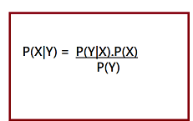

## Fig. 3 Naive Bayes theorem equation

The algorithm implemented in this project is Naive Bayes Classifier.

Naive Bayes classifier depends on Bayes Theorem

Equation 1:

P(Y|X1,… … … ..,Xn) = P(Y) P(X1,… … … ..,Xn)/ P(X1,… … … ..,Xn)

Where,

Y is the class variable

X1, X2, ….…., Xn are the dependent features

## So, the naive Bayes is a classification technique based on Bayes' Theorem with an assumption of independence among predictors. In simple terms, a Naive Bayes classifier assumes that the presence of a particular feature in a class is unrelated to the presence of any other feature.

## 3.4 System Architecture

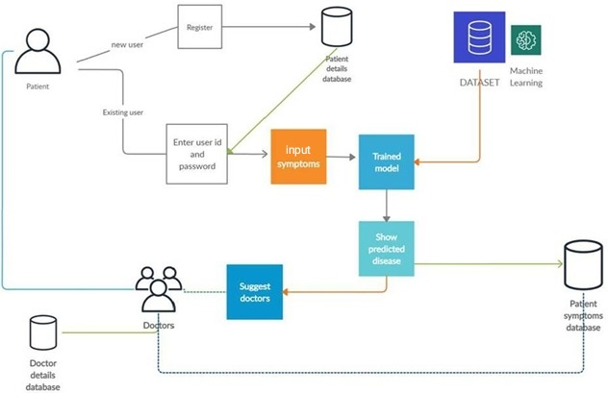

## Fig. 4 System Architecture

## (This is the general architecture of whole system used for the Medicator Application)

**3.5 Requirement Specification**

Following are some important requirements to be installed on developer’s system:

* + - 1. Ubuntu 18.04 LTS / Windows8 and up
      2. Python and pip
      3. Pandas
      4. Numpy
      5. Sckit-learn
      6. Django
      7. Pyrebase

## 3.6 Flowcharts / DFDs / UML

**USE CASE DIAGRAM**

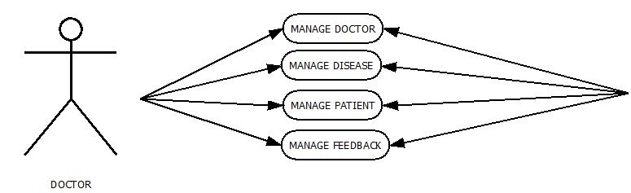

System

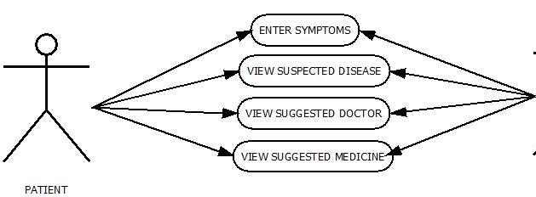

System

Fig. 5 Use Case Diagram

(This is the use case diagram used for the interaction between the system and patient

as well as system and doctor)

## 3.7 Design and Test Steps

**Design**:-

* + 1. **Homepage:**

This is the user interface of the homepage of the application. It consist of the basic information regarding the application as well as the team members. This page contains the navigation for login and sign up.



Fig. 6 Homepage

## PATIENT UI

**3.7.2.1 Sign Up:**

This module provides the form to login as a patient. On successful sign up you are redirected to the profile of the patient. It contains validation for all fields.

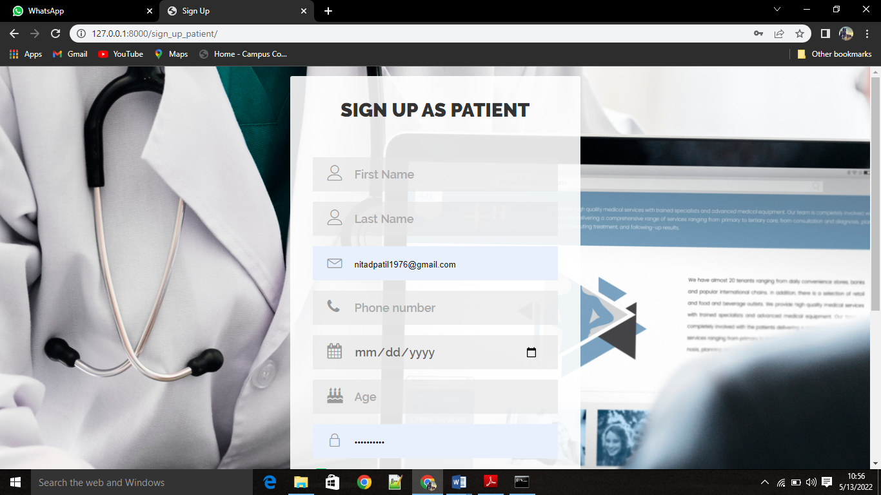

Fig. 7 Sign Up Page

## 3.7.2.2 Login:

## This module consists of form to login as a patient who is already registered to the application. On successful login it redirected to the patient profile page.

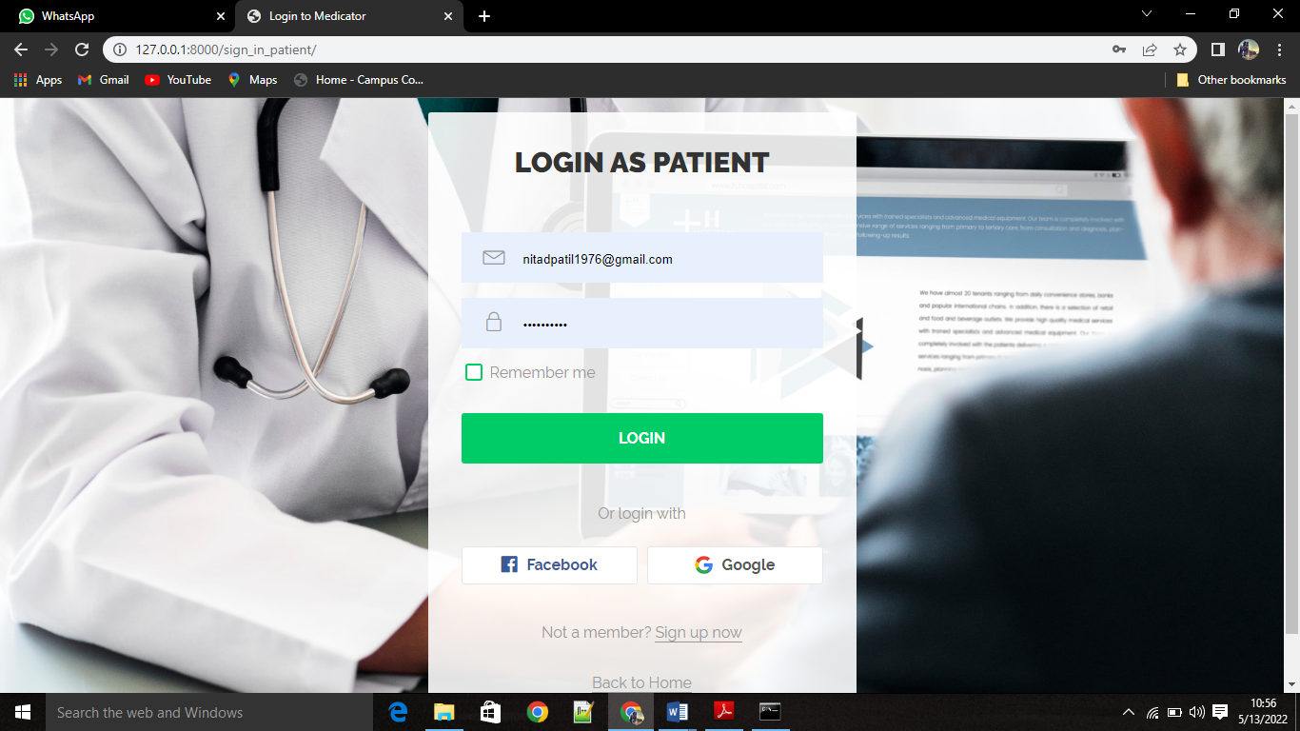

Fig. 8 Login Page

If user/patient enters invalid credentials pop up message is displayed saying that “Invalid Credentials” .

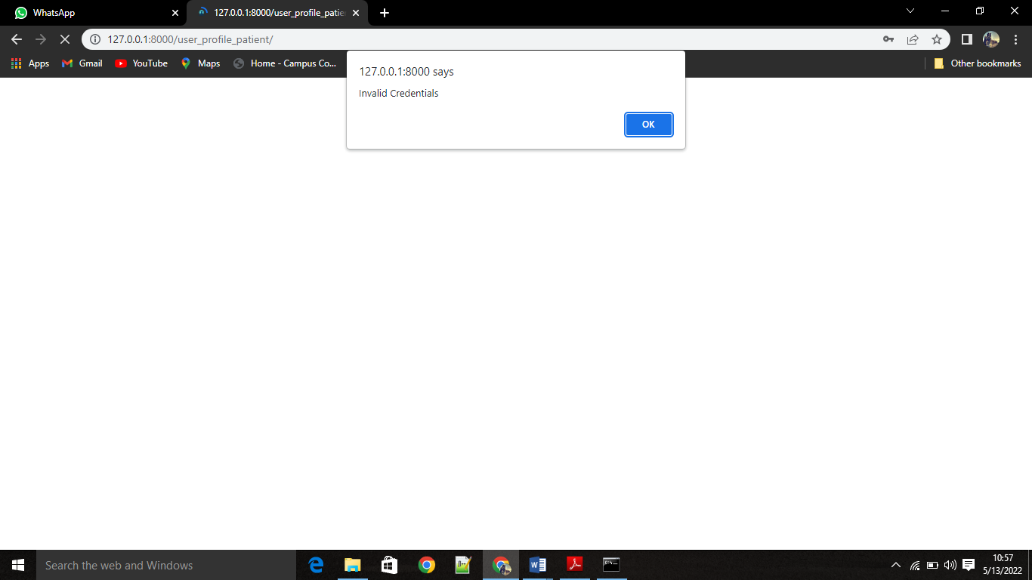

Fig. 9 Invalid Login Page

**3.7.2.3 User profile patient**

This module displays all the necessary information entered by the user at the time of registration. It also provides the facility of check disease and sign out from application.

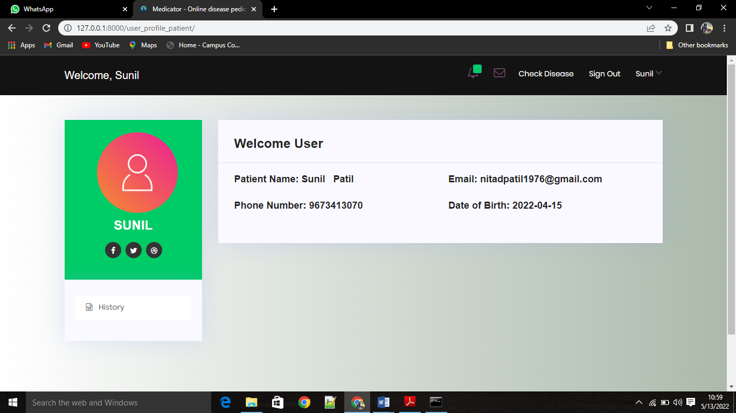

Fig. 10 Patient Homepage

## 3.7.2.4 Patient Pending requests:

## This module is responsible for displaying the pending requests made by patients to the relevant doctors. It also displays medical history of previous appointments and information regarding the disease.

## C:\Users\SONALI\Pictures\Screenshots\Screenshot (161).png

Fig. 11 Patient Pending requests

**3.7.2.5 Patient’s accepted requests:**

This module shows that doctor accepted the requests of the patient. It provides the facility to doctor to see notifications which is sent to the patient.

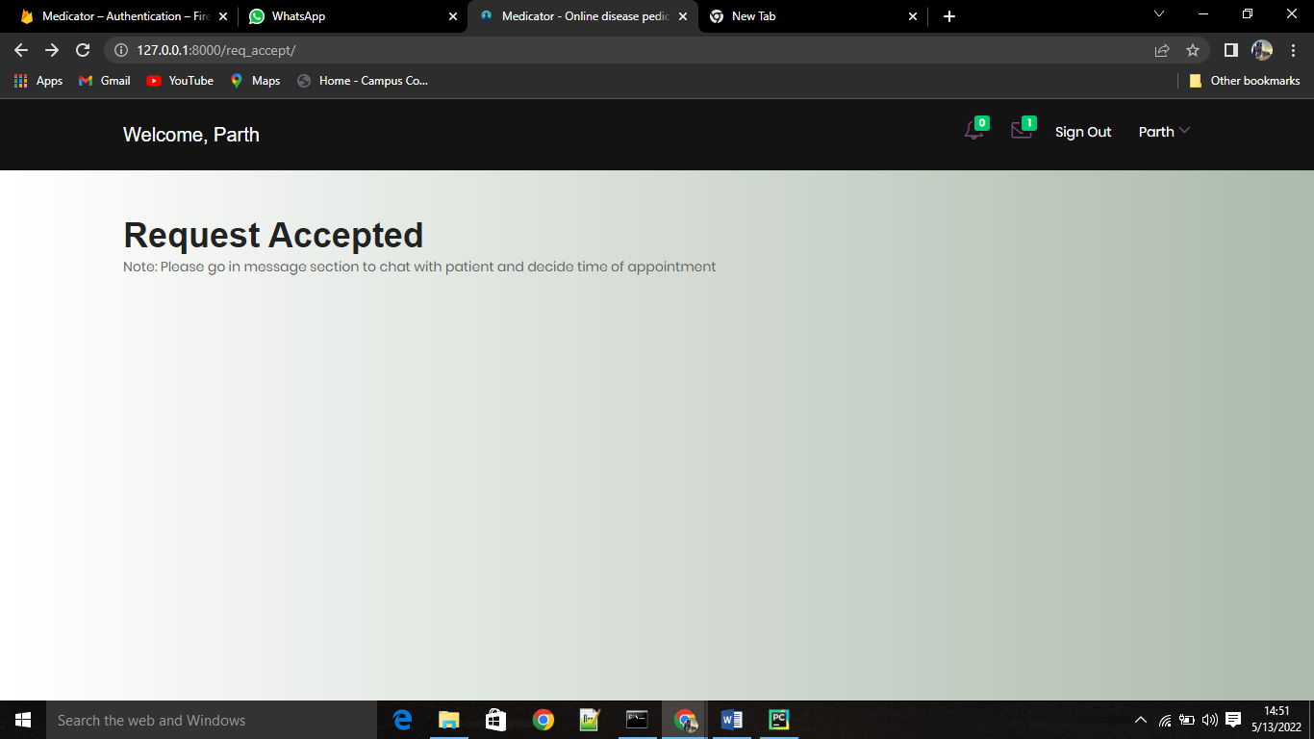

Fig. 12 Patient’s accepted requests

## 3.7.2.6 Input symptoms:

## In this module patient can enter the symptoms that he/she suffering. On submitting the request patient is redirected to the predicted disease module. To successfully predict the disease we have to enter minimum three disease symptoms.

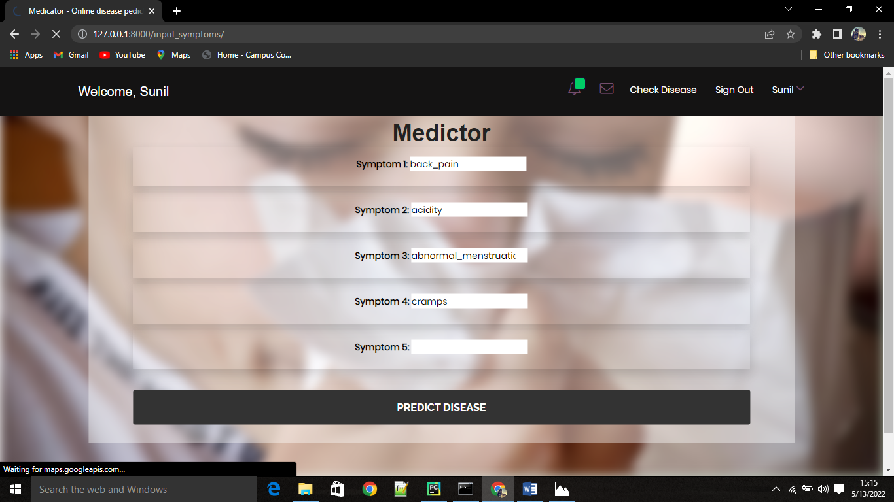

Fig. 13 Input Symptoms

**3.2.7.7 Predicted Disease:**

This module displays the corresponding results with three machine learning algorithms. We can also google the more information about the disease. This module also responsible for the providing information about most probable predicted disease as well as consulting the respective doctor.

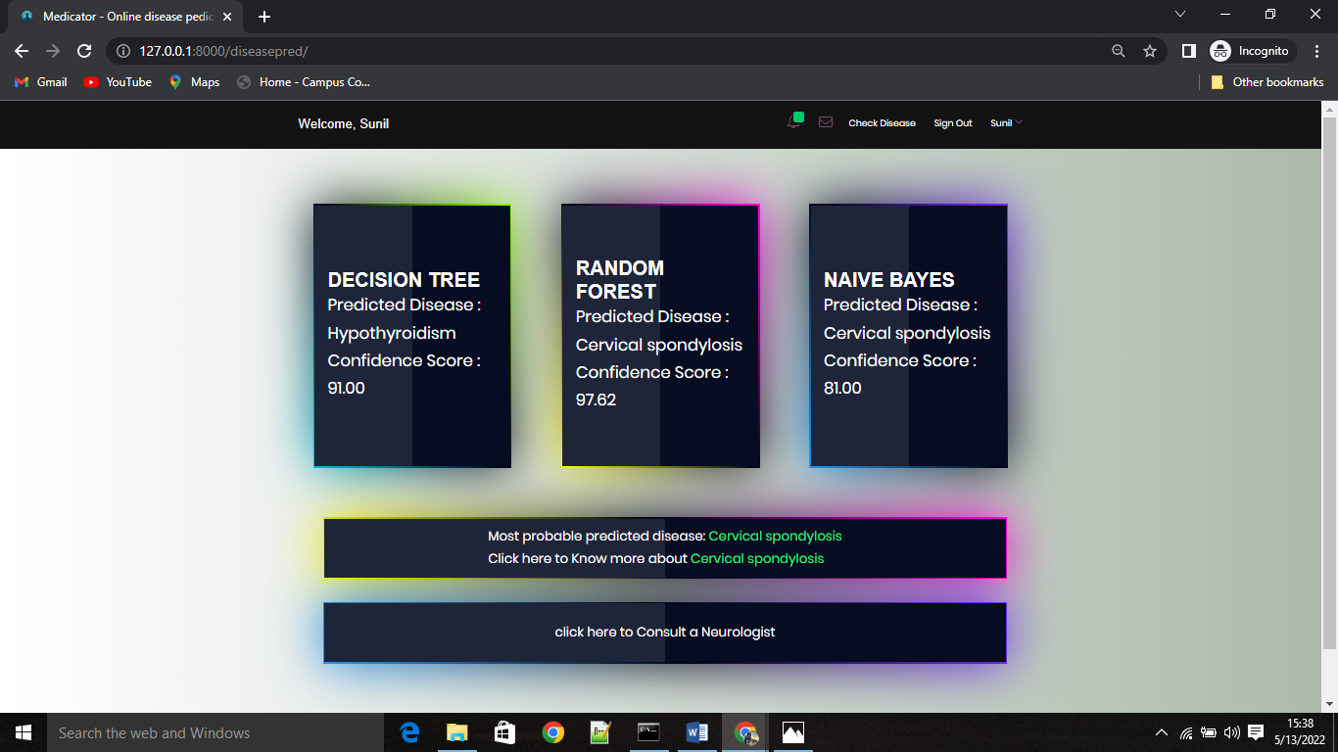

Fig. 14 Disease Predicted

## 3.2.7.8 Chat with doctor:

## This module provides the facility for patient to interact with the doctor with the help of chat.

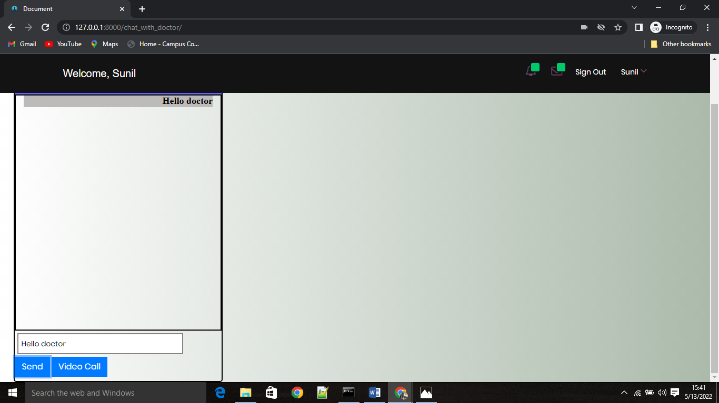

Fig. 15 Chat with Doctor

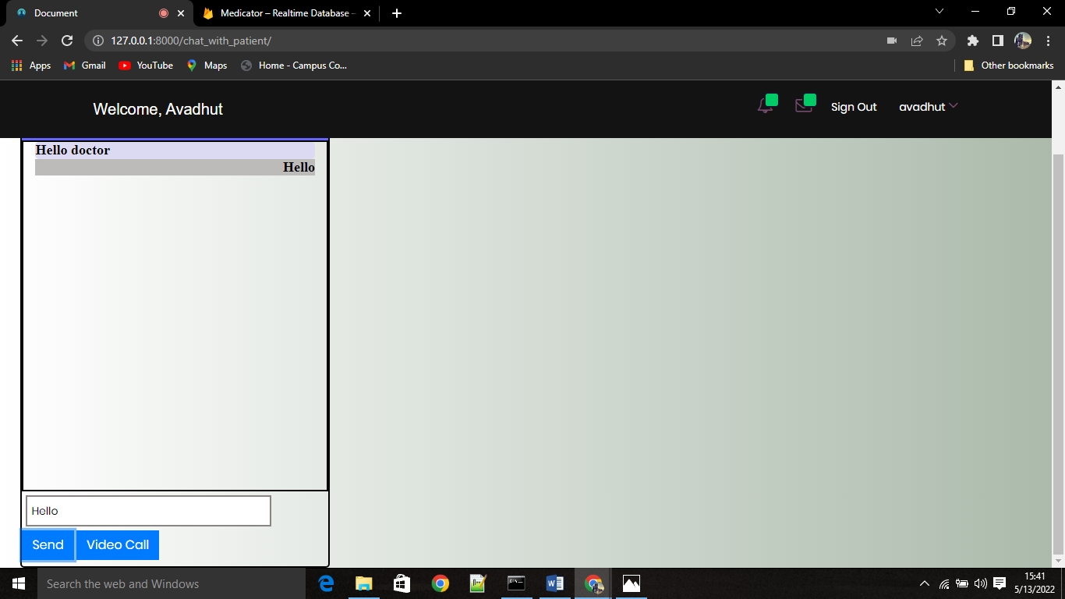

Fig. 16 Chat with Patient

* + 1. **Doctor UI:-**

## 3.7.3.1 Doctor profile:

This module displays all the necessary information entered by the user at the time of registration. It also provides the facility of check disease and sign out from application.

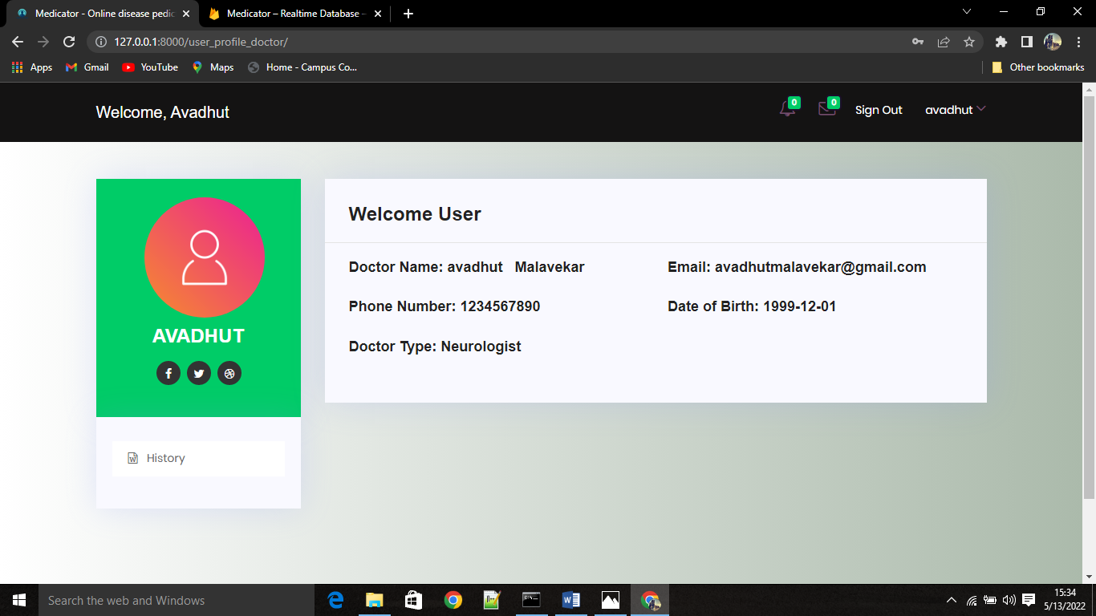

Fig. 17 Doctor Profile

**3.7.3.2 Consultation:**

## This module provides the facility for doctor to interact with the patient with the help of messages as well as video calls.

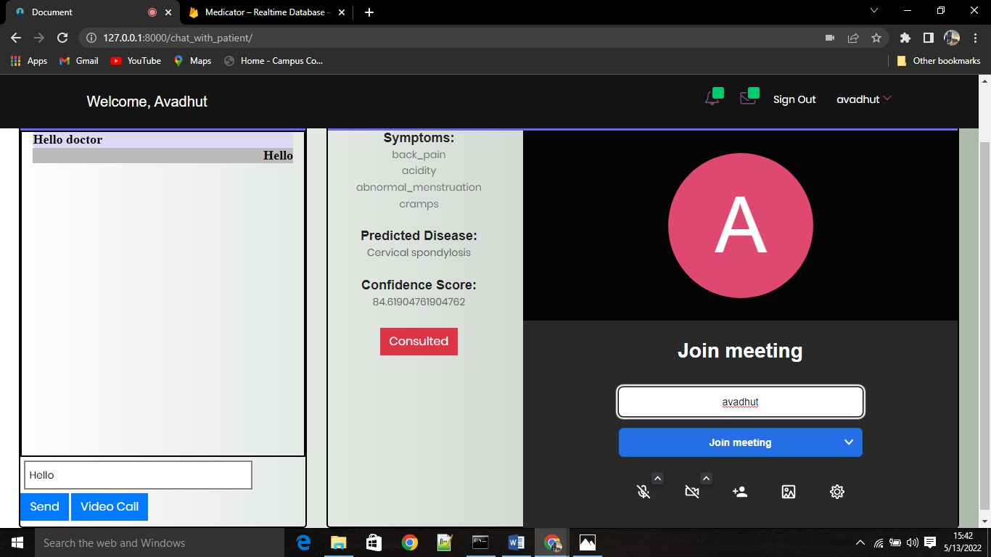

Fig. 18 Video Consultation

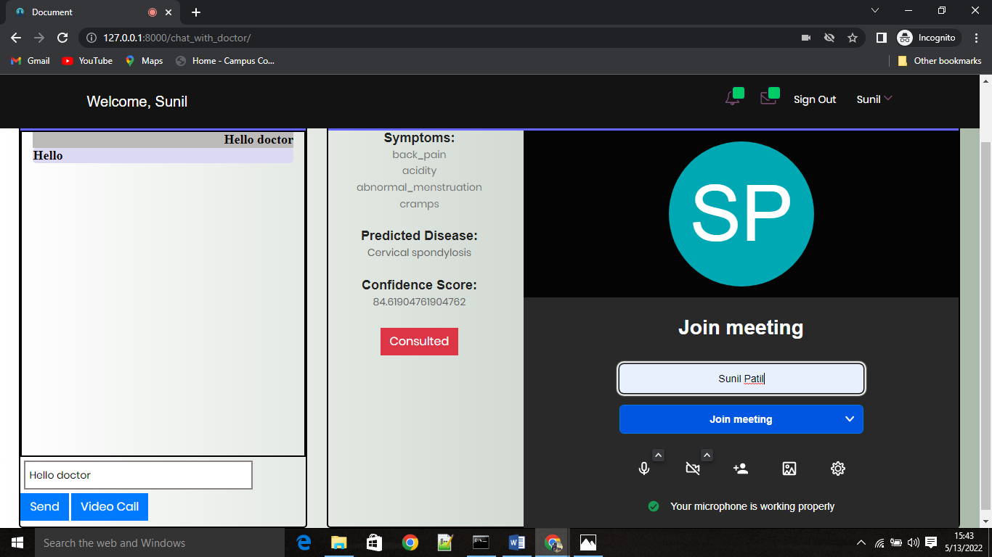

Fig. 19 Video Consultation



Fig. 20 Video Consultation



Fig. 21 Video Consultation

# Performance Study

## Implementation Environment:

## The below figures represents the implementation of application.

Fig. 22 Disease prediction algorithms

Fig. 22 Disease prediction algorithms (Cont.)

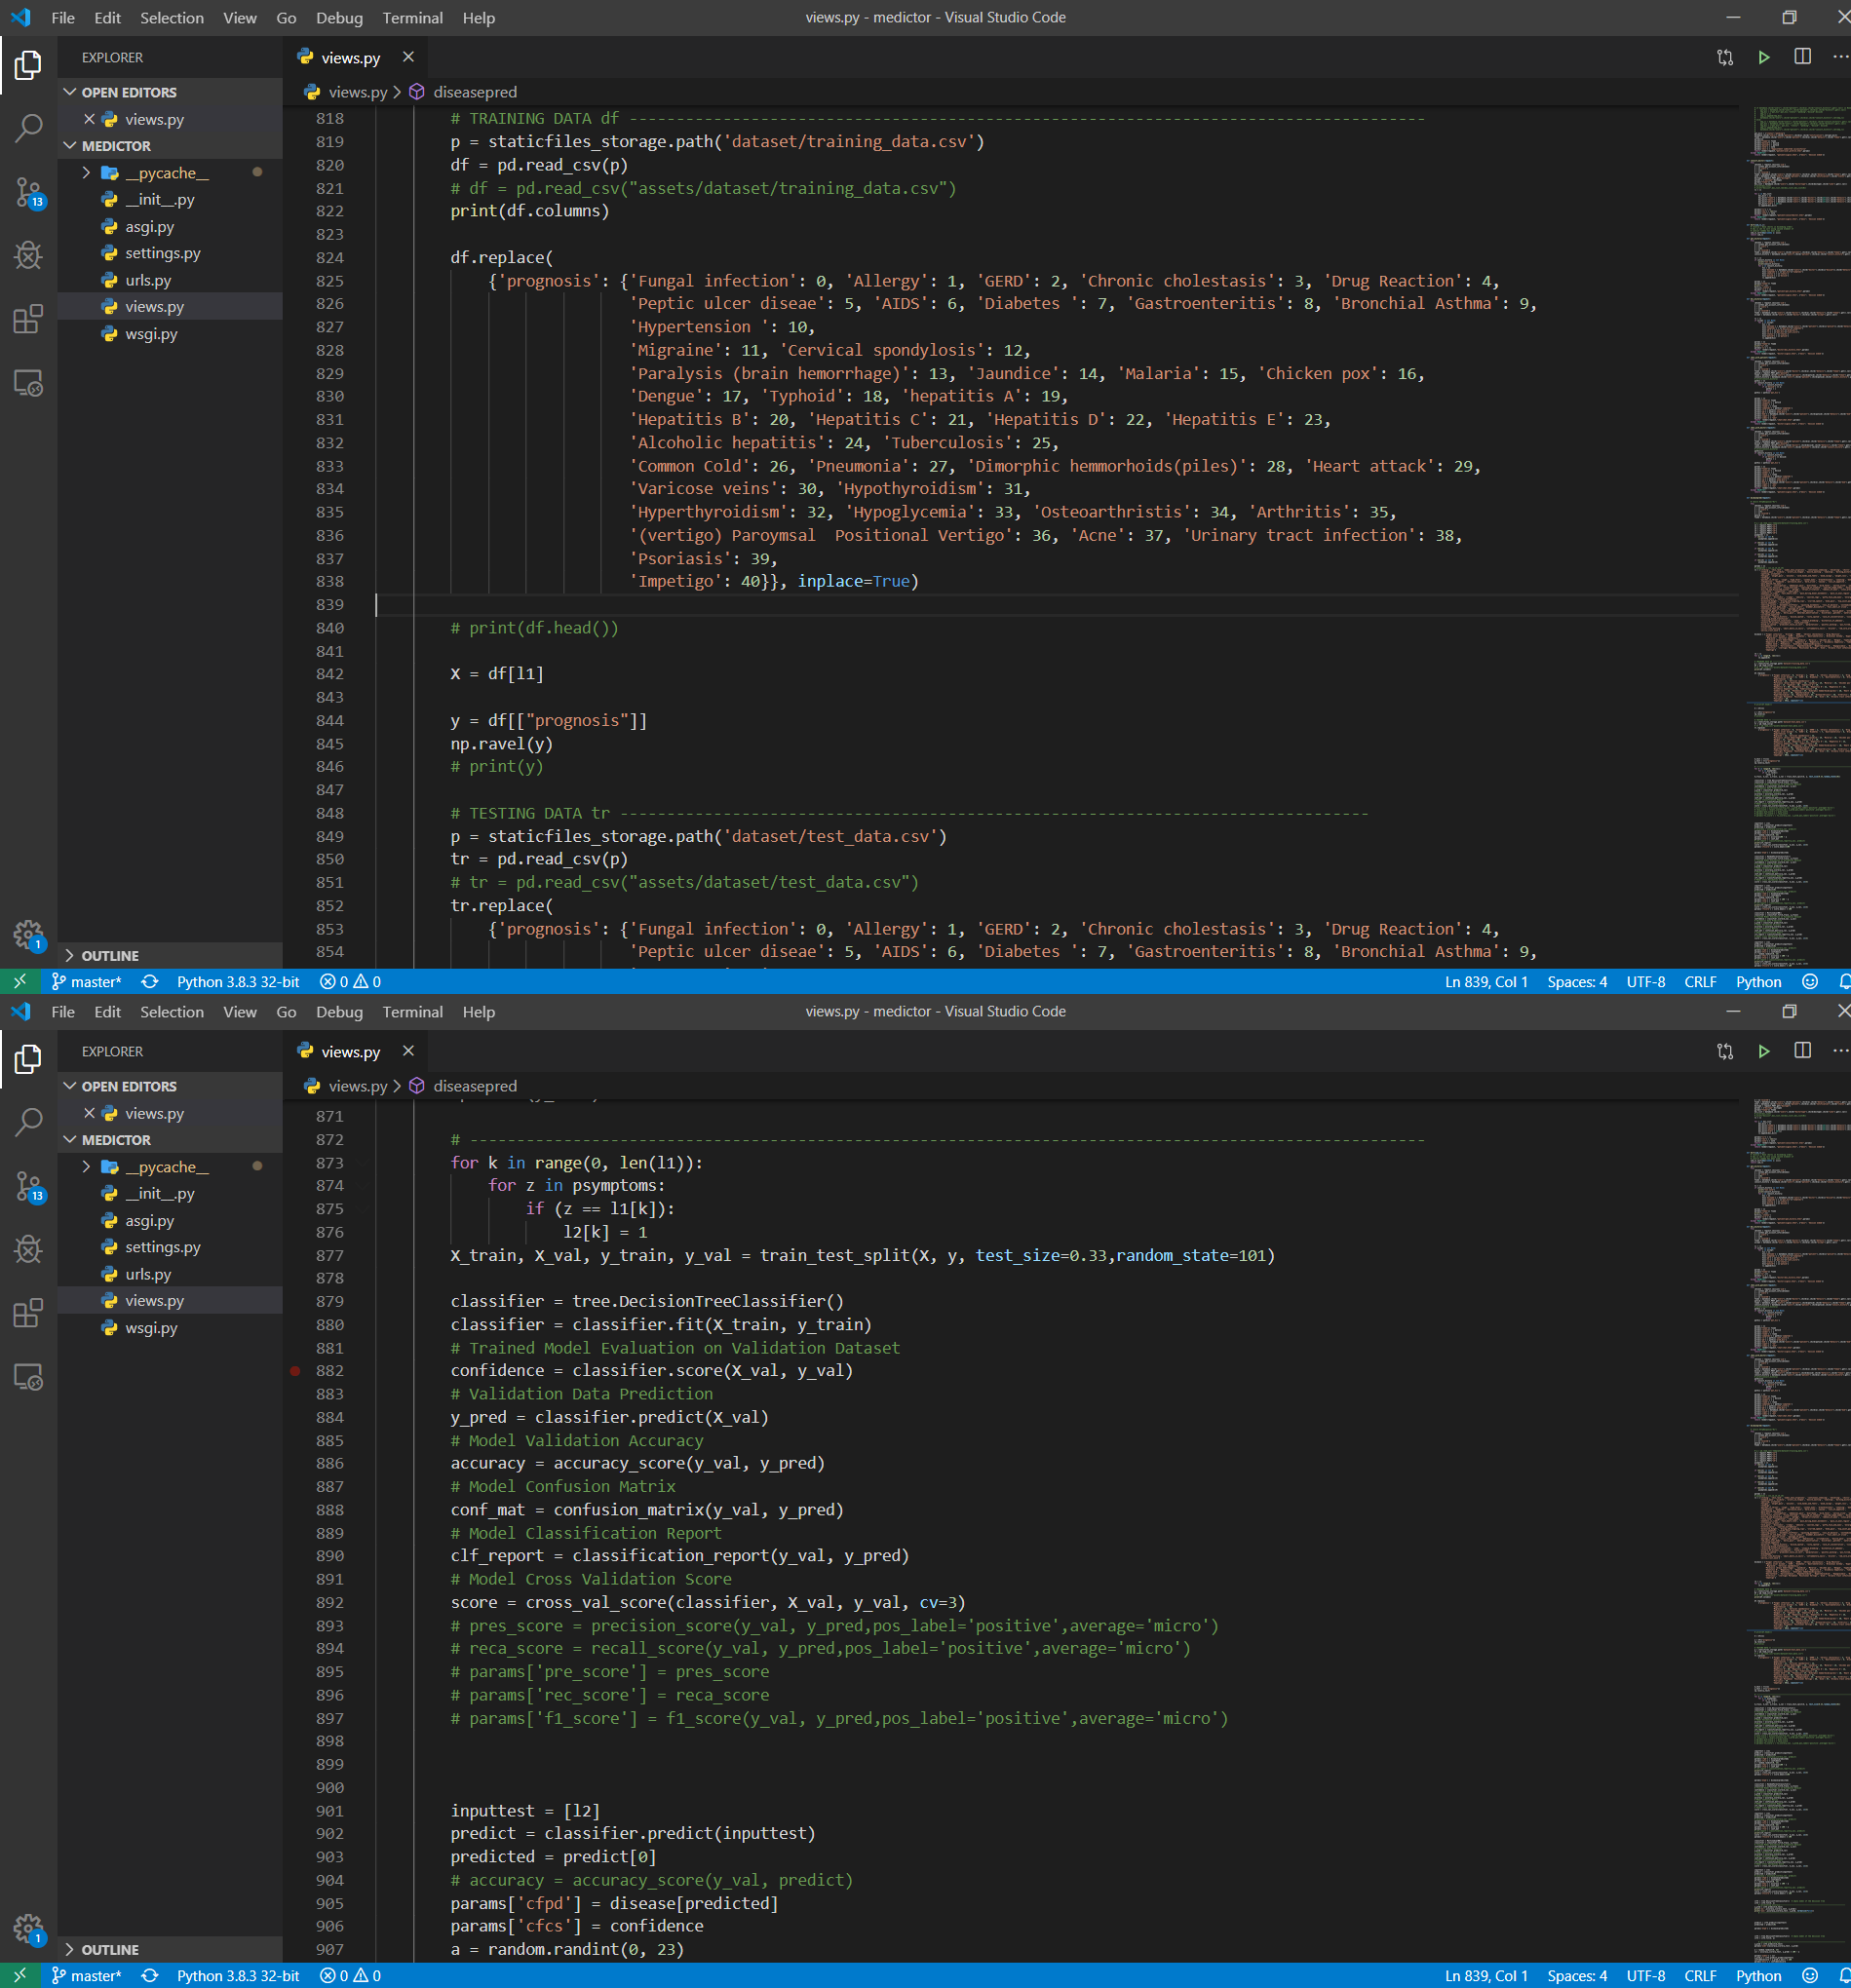

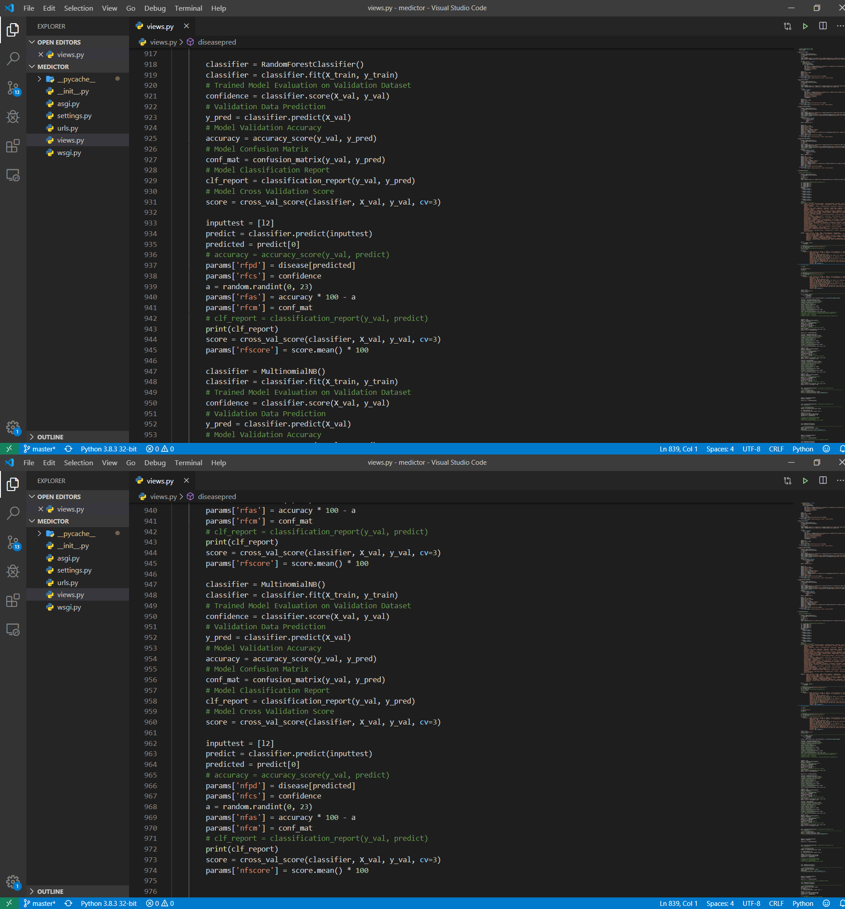

Fig. 22 Disease prediction algorithms (Cont.)

## Results and Analysis:

* Medicator application provides variety of benefits for both patient and doctor.
* The system helps the patients to consult the doctor at their convenience by sitting at home.
* User can search for doctor’s help at any point of time and can talk about their illness to get instant diagnosis.
* The expected outcome and scope of this project is that if disease can be predicted then early treatment can be given to the patients which can reduce the risk of life and save life of patients.
* Cost to get treatment of diseases can be reduced up to some extent by early recognition.
* The decision tree algorithm has given about 50% to 60% accuracy.
* The overfitting problem which occurs when decision tree algorithm is implemented, that is solved through the random forest algorithm which enhances the accuracy of the decision tree algorithm about 5% to 10%.
* The Naive Bayes has given about 60% to 65% accuracy.

## 5. Testing

**Module name: Sign Up as patient:**

**Test summary/Description:**

|  |  |  |  |  |
| --- | --- | --- | --- | --- |
| **Test condition** | **Test Data** | **Expected result** | **Actual result** | **Status** |
| Invalid email | Abc.xyz | Enter a valid email | Enter a valid email | Passed |
| Phone no with characters | 123abc | Enter a valid phone | Enter a valid phone | Passed |
| Password with length<=5 | 1234 | Enter a strong password | Enter a strong password | Passed |
| Empty any field | “ ” | Please fill this field | Please fill this field | Passed |
| Email already signed up | abc@gmail.com | User already exists | User already exists | Passed |
| All valid data | - | Registration Successful | Registration Successful | Passed |

**Module name: sign Up as Doctor:**

**Test summary/Description:**

|  |  |  |  |  |
| --- | --- | --- | --- | --- |
| **Test condition** | **Test Data** | **Expected result** | **Actual result** | **Status** |
| Invalid email | Abc.xyz | Enter a valid email | Enter a valid email | Passed |
| Phone no with characters | 123abc | Enter a valid phone | Enter a valid phone | Passed |
| Password with length<=5 | 1234 | Enter a strong password | Enter a strong password | Passed |
| Empty Field | “ ” | Please fill this field | Please fill this field | Passed |
| Email already signed up | abc@gmail.com | User already exists | User already exists | Passed |
| All valid data | - | Registration Successful | Registration Successful | Passed |

**Module name: Login as patient:**

**Test summary/Description:**

|  |  |  |  |  |
| --- | --- | --- | --- | --- |
| **Test Condition** | **Test data** | **Expected result** | **Actual result** | **Status** |
| Wrong email | abc@gmail.com | Invalid credentials | Invalid credentials | Passed |
| Empty Field | “ ” | Please Fill this field | Please Fill this field | Passed |
| Wrong Password | 12345 | Invalid credentials | Invalid credentials | Passed |
| All valid data | - | Redirected | Redirected | Passed |

**Module name: Login as Doctor:**

**Test summary/Description:**

|  |  |  |  |  |
| --- | --- | --- | --- | --- |
| **Test Condition** | **Test data** | **Expected result** | **Actual result** | **Status** |
| Wrong email | abc@gmail.com | Invalid credentials | Invalid credentials | Passed |
| Empty Field | “ ” | Please Fill This field | Please Fill This field | Passed |
| Wrong Password | 12345 | Invalid credentials | Invalid credentials | Passed |
| All valid data | - | Redirected | Redirected | Passed |

**Module name: Input and predict disease:**

**Test summary/Description**

|  |  |  |  |  |
| --- | --- | --- | --- | --- |
| **Test Condition** | **Test data** | **Expected result** | **Actual result** | **Status** |
| Five symptoms | Any five symptoms | processing | processing | Passed |
| Decision tree  Random Forest  Naïve Bayes | - | Display disease with probability | Display disease with probability | Passed |
| More Info | - | Display More information | Display More information | Passed |

**Module name: chat with doctor/chat with patient:**

**Test summary/Description:**

|  |  |  |  |  |
| --- | --- | --- | --- | --- |
| **Test Condition** | **Test data** | **Expected result** | **Actual result** | **Status** |
| Chat | message | Message Delivered | Message Delivered | Passed |
| Video call | - | Video meet | Video Meet | Passed |

## 6. Project Timeline

|  |  |  |  |  |
| --- | --- | --- | --- | --- |
| **Task** | **Start Date** | **End Date** | **Days** | **Hours** |
| Topic Presentation to Guide | 18-08-2021 | 05-09-2021 | 18 | 90 |
| Topic Presentation to Panel | 08-09-2021 | 15-09-2021 | 7 | 35 |
| Synopsis Preparation | 16-09-2021 | 28-09-2021 | 12 | 60 |
| Synopsis Presentation | 06-10-2021 | 10-10-2021 | 4 | 20 |
| Learning basics for the projects(Django,MLAlgo,Pyrebase) | 01-11-2021 | 29-11-2021 | 28 | 140 |
| Implementing basic template of the page | 11-01-2022 | 20-01-2022 | 9 | 45 |
| Adding Basic functions to the page | 26-01-2022 | 02-02-2022 | 7 | 35 |
| Patient & Doctor Module | 03-02-2022 | 10-02-2022 | 7 | 35 |
| Adding maps and other functions | 11-02-2022 | 15-02-2022 | 4 | 20 |
| Login(user and admin ) module and authentication in Pyrebase | 16-02-2022 | 28-02-2022 | 12 | 60 |
| Chat & Video Call Module | 01-03-2022 | 05-03-2022 | 4 | 20 |
| Admin Module | 06-03-2022 | 08-03-2022 | 2 | 10 |
| Testing | 09-03-2022 | 31-03-2022 | 22 | 110 |
| **Total** | | | **136** | **680** |

# 7. Conclusion and Future Work

## Future Work

1. Facility for modifying user detail.
2. More interactive user interface
3. Can be done as Mobile Application.
4. Payment Gateway integration for doctor’s consultation fee.

.

## Conclusion:

So, Finally I conclude by saying that, this **Medicator – Online disease prediction and doctor’s consultation** is very useful in everyone's day to day life and it is mainly important for the healthcare sector, because they are the main users who daily uses this system to predict the disease of the patients based on their general information and symptoms that they are suffering. Nowadays health industry play major role in curing the diseases of the patients so this is also some kind of help for the health industry and also it is useful for the user in case he/she doesn't want to go to the hospital or any other clinics, so just by entering the symptoms and all other useful information the user can get to know the disease that he/she is suffering from and the health industry also can get benefit from this system by just asking the symptoms from the user and entering in the system and in just few seconds they can tell the exact and up to some extent the accurate disease. If health industry adopts this project, then the work of the doctors can be reduced and they can easily predict the disease of the patient. The **Medicator** is to provide prediction for the various and generally occurring diseases that when sometimes ignored can turns into fatal disease and cause lot of troubles to the patient and as well as their family members.

# 8. References:

1. Optimizing Decision Tree Through Attributes Generation Using Genetic Programming for Clinical Data by Narander Kumar and Sabita Khatri | <https://indjst.org/articles/optimizing-decision-tree-through-attributes-generation-using-genetic-programming-for-clinical-data>
2. Medical Data Classification with Naive Bayes Approach by K.M. Al-Aidaroos, A.A. Bakar and Z. Othman | <https://scialert.net/abstract/?doi=itj.2012.1166.1174>
3. Machine Learning Full Course - Learn Machine Learning 10 Hours | Machine Learning Tutorial | Edureka <https://www.youtube.com/watch?v=GwIo3gDZCVQ>
4. Machine learning Algorithms -1) [https://machinelearningmastery.com/use- classification-machine-learning-algorithms-weka/](https://machinelearningmastery.com/use-%20classification-machine-learning-algorithms-weka/)
5. Django Documentation: <https://docs.djangoproject.com/en/3.1/>
6. Building Machine Learning Systems with Python - Willi Richert, Luis Pedro Coelho